PROJECT REPORT
ON
GIT HUB LINK : https://github.com/Tejasvi-Vij/Comprehensive-employee-data-of-a-startup-TK-/blob/main/Comprehensive%20employee%20data%20of%20a%20startup%20TK.xlsx
Comprehensive Employee Data of a Startup – TK
Program Name: BCA
Subject Name/Code: Data Science using excel
Submitted by:
Name: Tejasvi Vij
UID – 25BCD10099
Section: BCD2(B)
Submitted to:
Name: MR. RAJAT PATIYAL

1. Title
Payroll Management and Performance Improvement System

2. Aim of the Project
To create an Excel-based payroll management system that calculates employee salaries, increments, and performance metrics efficiently.

3. Objectives
- - To maintain employee salary data systematically.
- - To automate calculations of allowances, deductions, and increments.
- - To analyze payroll data using Excel formulas and statistical functions.
- - To find the mean, median, and mode of salary distribution.

4. Tools and Technologies Used
- - Microsoft Excel
- - Excel Functions (SUM, AVERAGE, MODE, MEDIAN, etc.)
- - Table Formatting and Conditional Formatting

5. System Requirements
- - Microsoft Office (Excel) 2016 or later
- - Windows 10 or above
- - Minimum 4 GB RAM

6. Logic / Formula Used
- - Net Salary = Payroll + Allowance – Deductions
- - New Payroll = Payroll × (1 + Increment Rate)
- - New Net Salary = Net Salary × (1 + Increment Rate)
- - Payroll Increase = New Payroll – Payrol

7 . SCREENSHOT OF THE PROJECT 

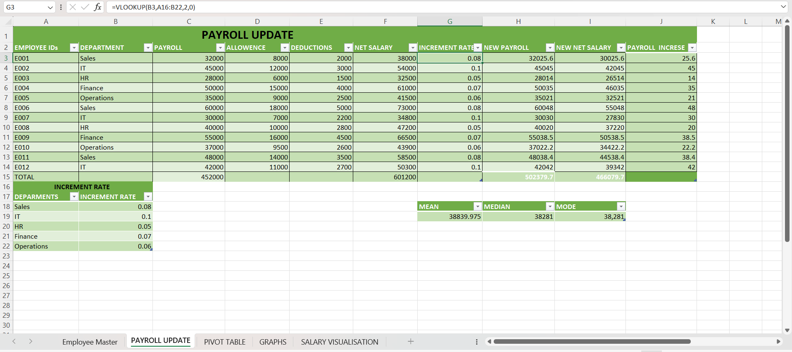

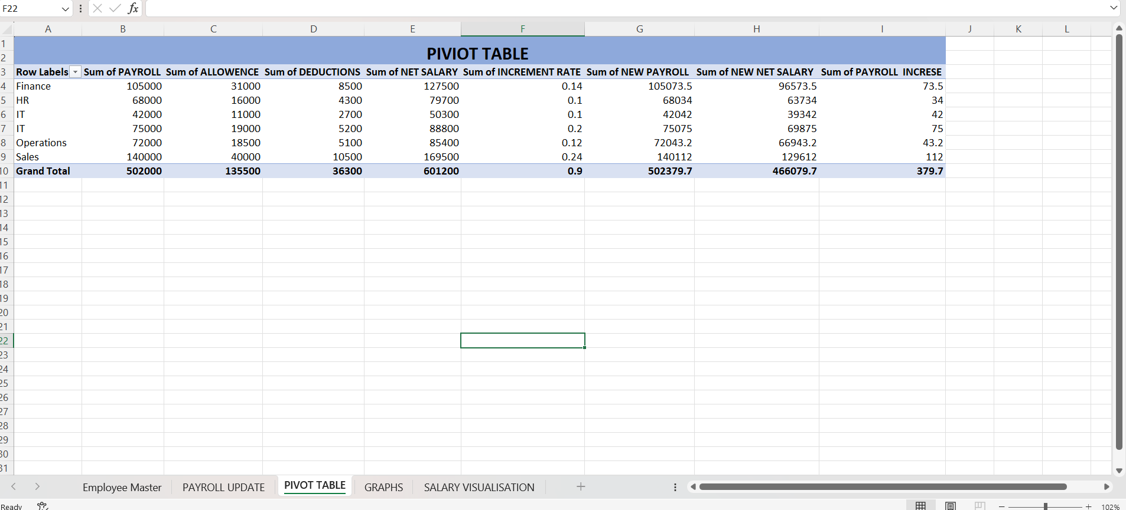

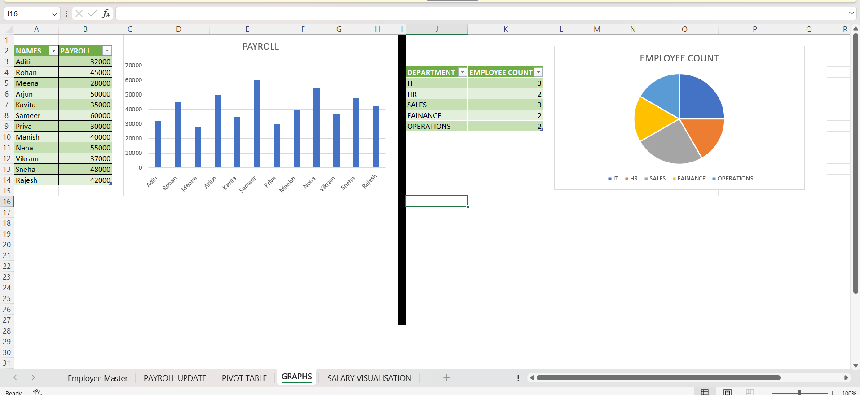

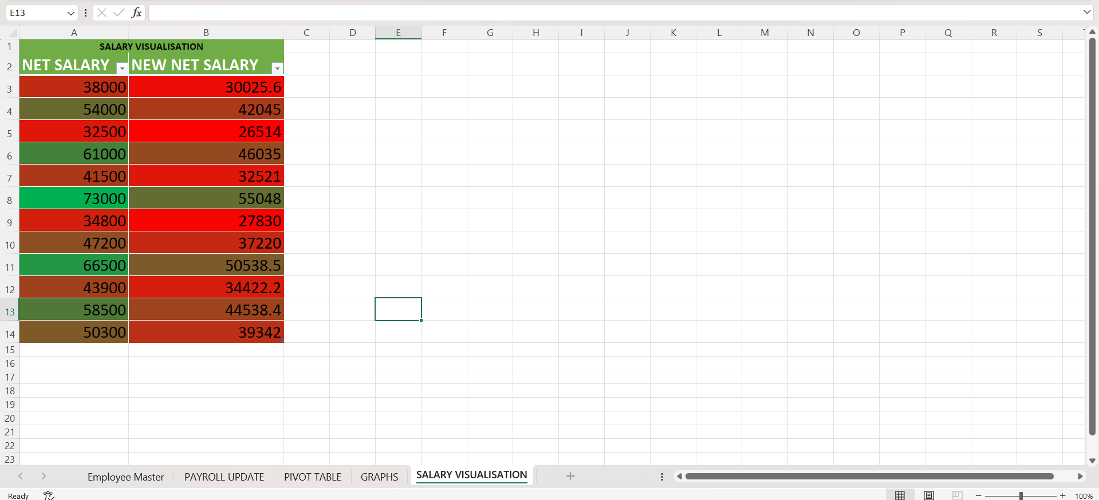

9.Conclusion
The project successfully demonstrates how Excel can automate payroll processes and analyze performance improvement effectively. It reduces manual errors and provides clear financial insights.

10. Learning Outcomes
- - Learned to use Excel formulas for payroll management.
- - Understood how to apply statistical tools in salary analysis.
- - Gained hands-on experience with data visualization and formatting.

11. References
- - Microsoft Excel Official Documentation
- - Chandigarh University BCA Practical Workbook
- - Online tutorials on Excel Formulas

